TOOTH MAP

This page is to help you understand the layout of your mouth. To speed things up your dentist gives each of your 32 adult teeth a notation, but it’s actually very easy to follow. The mouth is divided into 4 sections, your upper left side, upper right, your lower left and your lower right. There are 8 teeth (assuming you have all your teeth!) in each section.

Working from the front to the back, each one is given a number of 1 to 8. To shorten the notation instead of writing “Upper Left 4” the dentist would write “UL4”. Below you can see each of the teeth with its notation and remember, the dentist is looking at YOUR teeth so YOUR upper LEFT 4 is on the dentist’s RIGHT hand side.

YOUR UPPER RIGHT YOUR UPPER LEFT

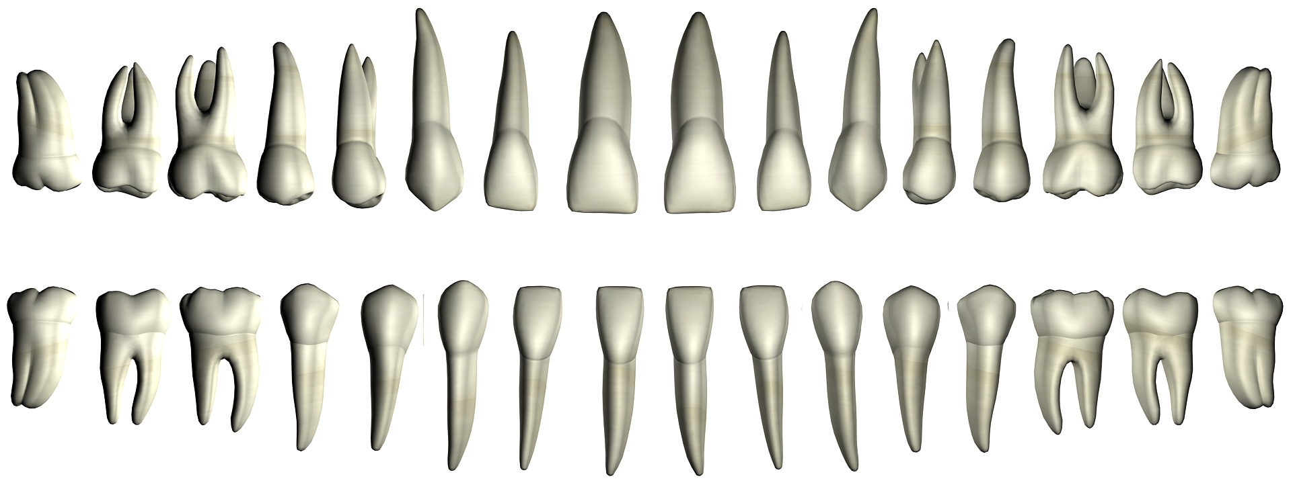
UR8 UR7 UR6 UR5 UR4 UR3 UR2 UR1 UL1 UL2 UL3 UL4 UL5 UL6 UL7 UL8

(wisdom) (------ molars-----) (-- pre-molars --) (Canine) ( --------------------- incisors -------------------) (Canine) (--- pre-molars ---) (----- molars -----) (wisdom)

LR8 LR7 LR6 LR5 LR4 LR3 LR2 LR1 LL1 LL2 LL3 LL4 LL5 LL6 LL7 LL8

YOUR LOWER RIGHT YOUR LOWER LEFT

